**EXPERIMENT-16**

**AIM:**

To clone an existing Virtual Machine using Oracle VirtualBox and test the cloned VM by booting and verifying its functionality, as well as validating the capability to revert to or run the previous version.

**PROCEDURE;**

1. **Cloning the Virtual Machine** 
   1. **Open VirtualBox** on the host system.
   2. Select the existing Virtual Machine to be cloned from the VirtualBox Manager.
   3. Click on the **Machine → Clone** option or right-click the VM and select **Clone**.
   4. Enter the name for the cloned VM (e.g., MyVM_Clone).
   5. Choose the **Clone Type**:
      * **Full Clone** (creates a full, independent copy).
      * **Linked Clone** (depends on the original VM’s disk, smaller in size).
   6. Select **MAC Address Policy** → typically, choose **Generate new MAC addresses**.
   7. Click **Next → Finish** to start cloning.
   8. Wait until the cloning process is complete.
2. **Testing the Cloned VM** 
   1. From the VirtualBox Manager, select the newly cloned VM.
   2. Click **Start** to boot up the cloned VM.
   3. Verify that the cloned VM boots successfully without errors.
   4. Check operating system functionality (e.g., log in, run sample applications).
3. **Loading Previous Version (Original VM)** 
   1. Select the **original VM** from the VirtualBox Manager.
   2. Click **Start** to boot the original VM.
   3. Ensure that both versions (original and clone) run independently without conflict.

**STEP 1:**

**STEP 2:**

**STEP 3:**

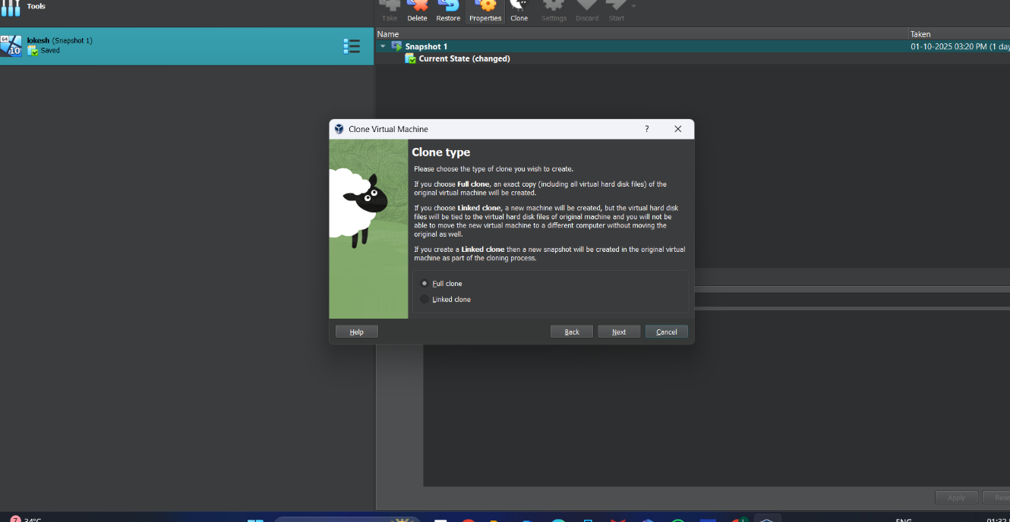

**STEP 4:**

**STEP 5:**

**RESULTS:**

* + Successfully cloned a Virtual Machine using Oracle VirtualBox.
  + Verified functionality of both the cloned and original VMs.
  + Demonstrated that the cloned VM can be used as a backup or alternate configuration while preserving the original system state.